West Sussex Mediation Service
Park House, North Street, Horsham, RH12 1RN
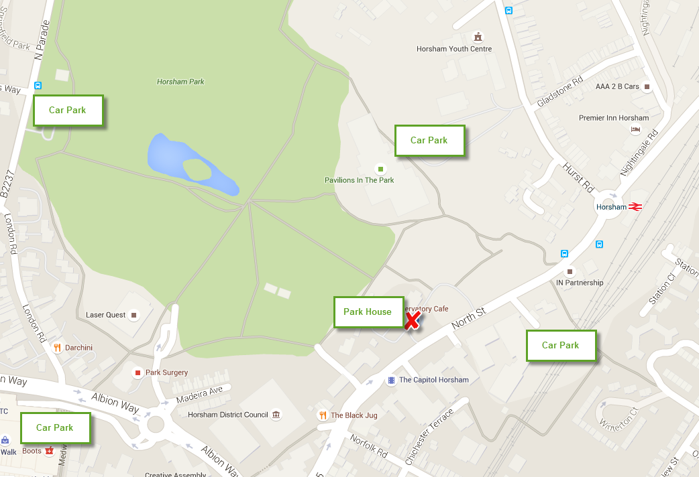
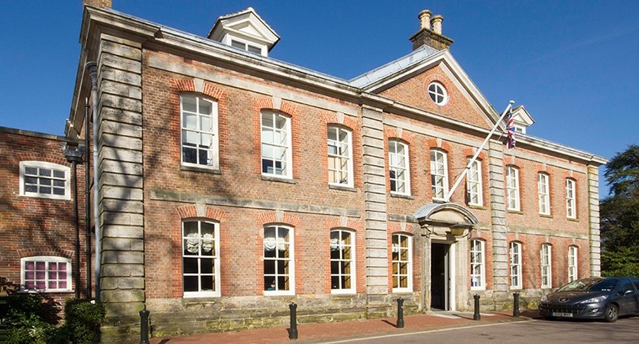

The meeting room is at our office on the 1st Floor of Park House, almost opposite the glass-fronted Capitol Theatre. If you are travelling via Horsham Railway Station, walk towards the town centre along North Street. Park House will be on your right behind a wall. DO NOT rely on Sat Nav taking you to the correct location – try RH12 1RL

Intercom for access
This is on the right as you enter the main wooden door. Press the ‘WSMS’ button and speak. Wait there and someone will come down and escort you.
There is parking around Park House but it is usually busy. The nearest pay and display car parks are behind the BT Exchange and at The Pavilions in Hurst Road. There are also car parks in the town centre (see map).

