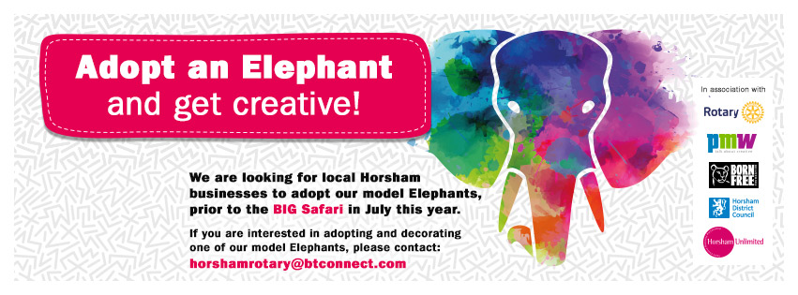

Elephant Owners Guide

Guide for Prospective Elephant Adopters ( Purchasers)

Event Outline

Elephantastic is a follow up to the hugely successful Giraffe Trail in Horsham which ran for 2 weeks in autumn 2013….. but is going to be even BIGGER !! It is planned to have about 100-150 Elephants scattered throughout the Town and the surrounding Countryside over a 5 week period this summer…starting on July 25 and concluding on August 30th. There will also be a variety of associated events and competitions to entertain the whole family.

The aims of the event are to promote:
…..our wonderful Town and surrounding countryside, and bring visitors from far and wide to see and participate in this fantastic event. As a result, to improve circulation throughout the Town Centre and in turn dwell time and turnover opportunities for all shops and cafes along the route.
…..to raise awareness of the individual locations, businesses and organisations that host the elephants
…..to promote art and local artists
…..to raise funds and awareness for many charities that are active in Horsham District
…..to raise funds for the Born Free European Elephant Sanctuary
…..to create a fantastic community spirit by involving as many local organisations and people as possible

Elephantastic is organized and managed by The Rotary Club of Horsham, supported by the Town Business Partnership, Horsham Unlimited CIC Ltd, and Horsham District Council. In addition local charity Born Free is a partner to the overall event due to their fantastic work with the conservation of wildlife and their current campaign to create an Elephant Sanctuary in Europe. Born Free will receive approx. 25% of the overall proceeds of the event ( excluding the proceeds from the sale of the elephants at the conclusion of the event in late Autumn). Marketing and PR Agency, PMW Communications of Billingshurst, is also very generously supporting the Marketing and PR of the Project free of charge and website guru Steve Goodwin will be building and running the website for the Event ; and Gavin Hewins, creator and manager of the Visit Horsham website and the Horsham Facebook page will create and manage the ELEPHANTASTIC Facebook page.

Basic Event Operation

The basic stages of Elephantastic are.

1… local Businesses and Organisations purchase (adopt) a ‘naked ‘ elephant

2… the purchasing organization chooses a local charity from a Register of approved Charities who will become a partner with the purchaser and jointly arrange for the elephant to be painted or decorated.

3…. the decorated Elephant will form part of an Elephant Trail during 5 weeks of the school’s summer holiday. The Trails will be in and around Horsham. If the adopter has a shop or location where an elephant can be displayed to the public every day during normal shop hours, the elephant will be displayed at that location. If not, the organisers will arrange for an appropriate display location. Competitions and events associated with the elephants, including Competition Trails which will require contestants to visit every elephant in a Trail will also take place during this period to raise funds for the participating charities. Souvenirs will also be available for sale…again, with the proceeds benefitting the involved charities.

4….The elephants will be sold after the summer with most of the proceeds going to the charity associated with each elephant. Some elephants will be sold via online bids, but most of the artistic ones will be sold at a Public Auction in late autumn.

How do I join ELEPHANTASTIC by adopting an Elephant ?

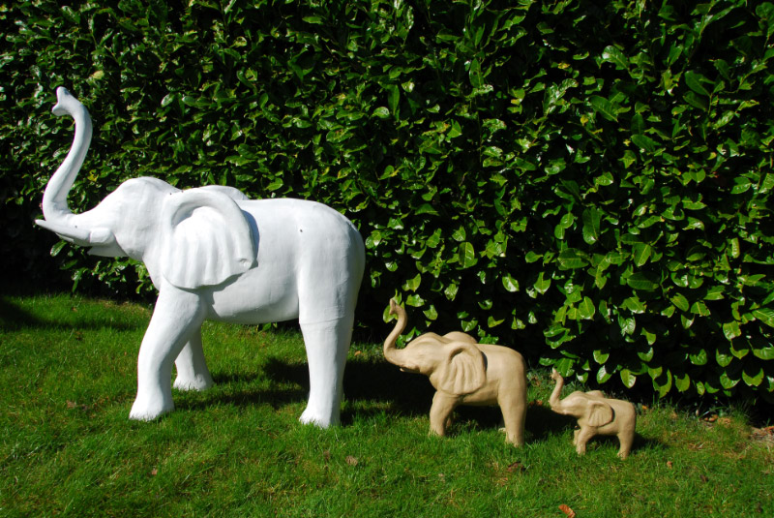

The Elephants are made of cardboard pulp. They weigh little but are fairly strong as a result of the way they are constructed. They can be painted or/decorated by various means. If you would like to adopt an Elephant you can select which type of Elephant you would like. The options are.

1……Large = Size 1 metre high x 1 metre long x 40 cm wide. These come in 6 parts plus 2 Tusks and have to be assembled using glue and possibly papier mache or filler. The purchase price is £130. They can possibly be delivered pre–assembled but supplies of these will be limited and are subject to availability and will be priced at £150. A white cardboard plinth for the elephant to stand on when displayed will also be provided.

2….. Medium = Size 50cm High x 48cm long x 12cm wide. These are considerably smaller and require no assembly. They cost £75 each.

3….. Family = A family of 1 Large ( unassembled ), 1 Medium and 1 Small (size12 x 30 x 28cm ) can be purchased for £200. These can be very striking after painting. (Note… the small ones will be sold as souvenirs to the general public but they are not available as display elephants in the trails except as part of a family )

For Display and Auction/Sale purposes the Elephants will be divided into ‘ Pieces of Art’ probably produced by an Artist; and ‘Fun Elephants’ which are probably decorated by it’s adopters or the associated charity or a school or community group. We would suggest that Fun elephants should probably be made using the largest size, or as a family, as they are likely to stand out more when on display; the Arty Elephants could be either size but there may be an advantage with the medium size as it comes as one piece and is therefore smoother….It may also be easier to sell at a high value as it easily fits any home or office or shop and therefore may attract a greater demand.

Numbers of elephants are limited and will be sold on a first come / first served based on receipt of payment. Payment can be made by.

Bank Transfer to the Rotary Club of Horsham Bank Code 40-24-33 Account
Number 11289829… HSBC Horsham

Or by

Cheque to Rotary Club of Horsham, Birkdale, Greens Lane, Mannings Heath,
W. Sussex, RH13 6JW

Naming an Elephant

All elephants will be decorated/painted by the owners or associated charity or someone appointed by them. It is aimed to produce a list of artists who are willing to paint one or more elephants. The Theme for Decorating the elephants is ‘ LOVING LIFE’ which relates to the objective of Born Free’s European Elephant Sanctuary which is to allow the elephants to which it will become home, to enjoy the rest of their lives.
How the artists and decorators interpret the phrase ‘ LOVING LIFE’ is of course totally up to their creativity. Each Elephant or Family should be given a Name which reflects how it has been decorated …ie the Title of the elephant as a piece of art such (Sun Rising over Horsham). This name including spaces should not be longer than 24 letters. Each elephant or family should also be given a nickname which will be the name by which it is affectionately known ( such as Fred )….and this should not be more than 12 letters. For auction and sale purposes the longer name will be used to identify the Elephant…in sale catalogues etc. ( as an example the During the Safari Trails, entrants to the Competition may need to find the nicknames which will only ever be shown on a display plaque which will be adjacent to each elephant.

Delivery of Elephants
Elephants will be delivered to their purchasers during late April/May. The decorating of the completed Elephants will need to be completed between about 9th July and 17th July as they are required to be returned to the organisers during that period for publicity events on the 12th July and , probably, the 20th July, prior to the formal opening of Elephantastic on 25th July..

Partnering with a Charity
The organisers will produce a Register of approved Charities for the event which hopefully should include all charities that have significant operations in the Horsham area… both large and small. The purpose of the Register is to ensure that all involved Charities are willing to work with the event’s social media and help promote the event. This Register should be completed by end April. Owners who purchase prior to the completion of the Registry can advise us when they make their purchase which Charity they would like to support and the organisers will do their best to make this happen. As with the Giraffe Trail, the organisers would like to see a good cross section of local Charities involved and therefore there will be a limit to the number of Elephants that any one Charity can be involved with- probably 5. Charities will be requested to accept the requests from Elephant owners to signify that they are prepared to work with the requesting Owner.

The proceeds of the event in terms of donations, competition fees and sponsorship and similar revenues will be divided between the participating charities in proportion to the number of elephants and after deducting associated costs and a donation of c 25% to Born Free.
Proceeds from the sale of the Elephants (after deduction of sales costs ) will go to the Charity involved with a specific Elephant except for c 10% which will be spread across all elephants. (We will take soundings on what the exact % should be with the owners as we go forward) The purpose of this is to spread the benefits more evenly across the charities in the case of elephants that fetch large sums or very small sums when sold.

How to Decorate your Elephant
Your elephant is ideally suited to being decorated by Decoupage or by painting. Further advice on this matter will be given to purchasers on delivery.

Help with Painting an Elephant
If you need help with the painting of an ‘arty’ Elephant the organisers intend to prepare a list of artists that are willing to produce one. Of course there may not be enough to satisfy the demand. ..so it would help if you know an artist yourself.

Celebrity Signing
In order to maximise the value of an Elephant Giraffe, it is also recommended to try to get the elephant ‘signed’ by a Celebrity or sports team or similar. They do not necessarily have to sign the actual elephant and could provide a signed photo or other endorsement BUT it should always mention Elephantastic …and you could consider providing a small elephant for them to ‘personalise’. They are included in a ‘family’ or can be purchased separately for £17.

Display Materials
Each Elephant will have a personalized ‘plaque’ when they are on display which will detail the name of the Business that owns the Elephant, the Name of the associated Charity, Name of any Celebrity, and the name of the Artist (s). Also the Title of the Elephant as a piece of Art and the Nickname.

